

**Touchstones**

***Netcards***

**Authority & Leadership Netcards with Text**

Axe HRJ

Boss HRJ

Buddha HRJ

Celebrate HRJ

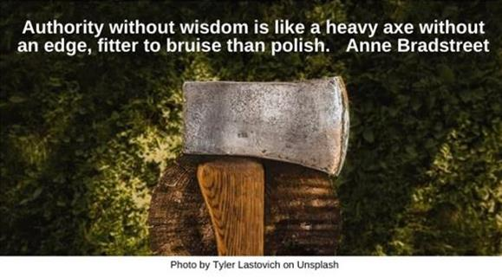

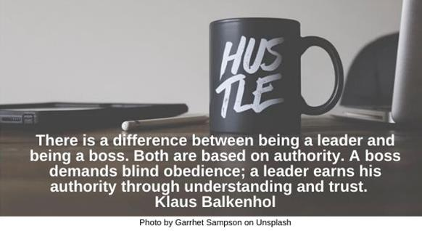

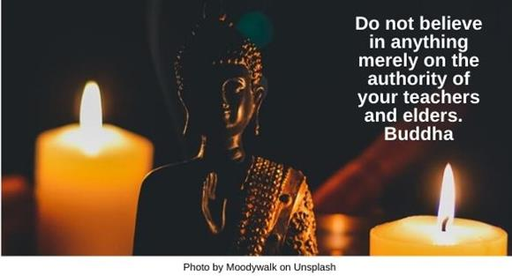

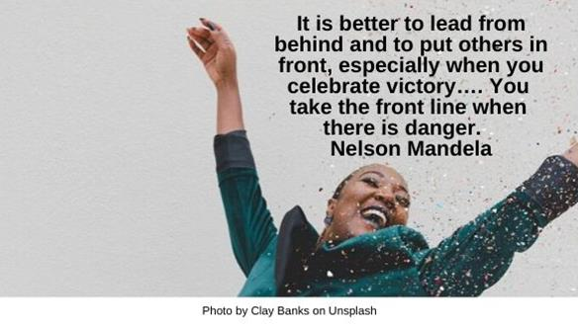

Comfort Zone HRJ

Darkness HRJ

Dawn HRJ

Desert HRJ

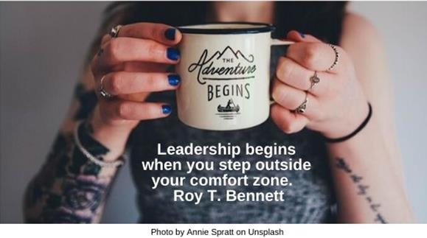

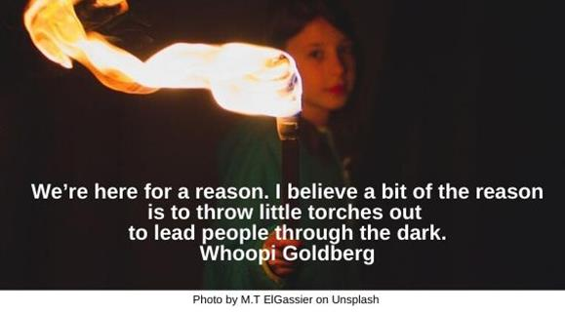

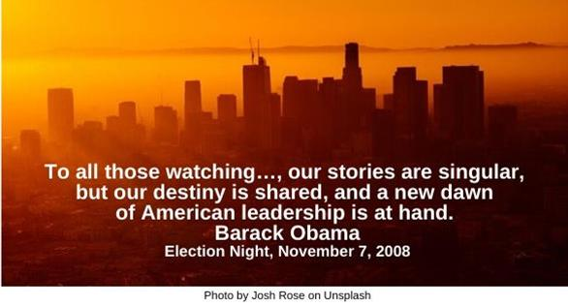

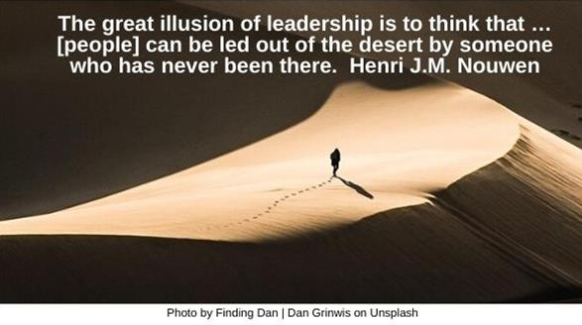

Dream HRJ

Einstein HRJ

Flag HRJ

Galileo

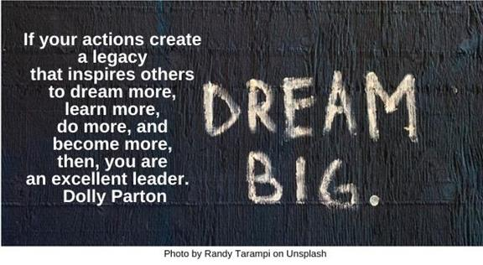

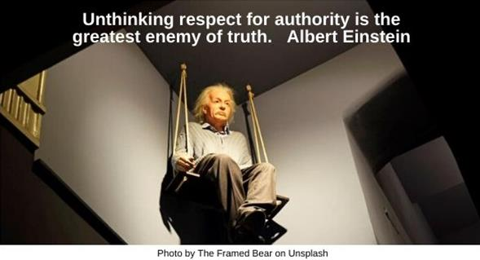

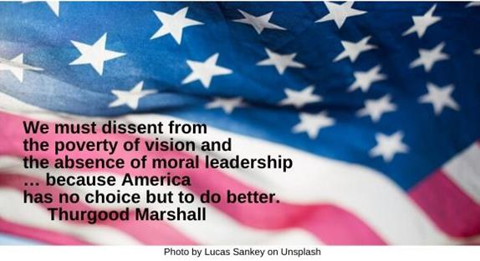

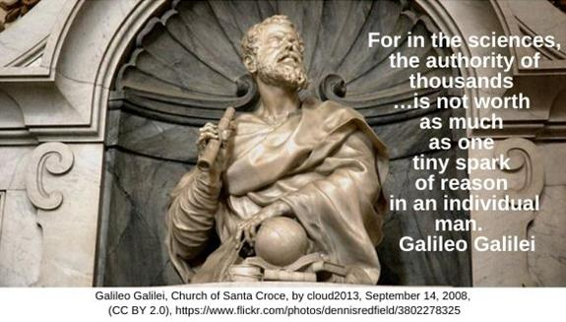

Gandhi HRJ

Ideas HRJ

Ignore Authority HRJ

Imagination HRJ

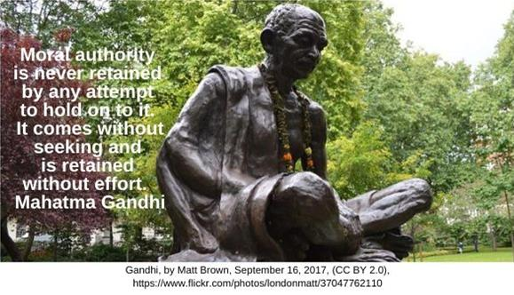

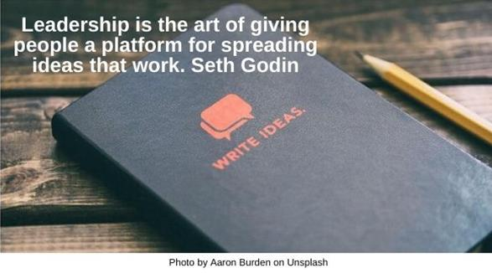

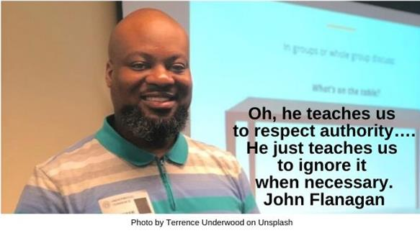



Jazz HRJ

Ladder HRJ

Line HRJ

Love HRJ

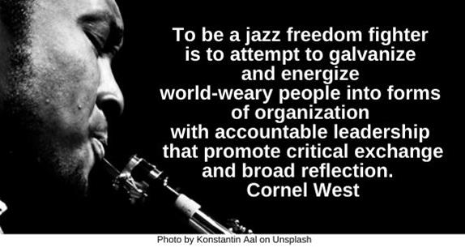

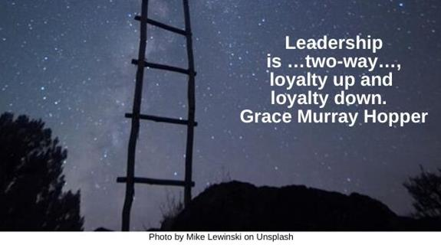

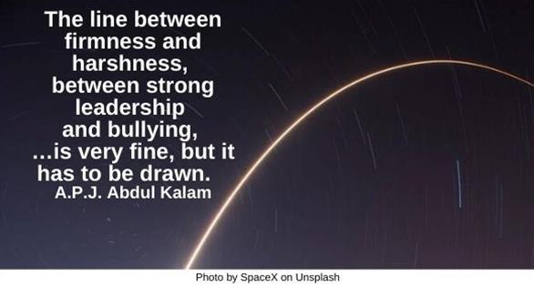

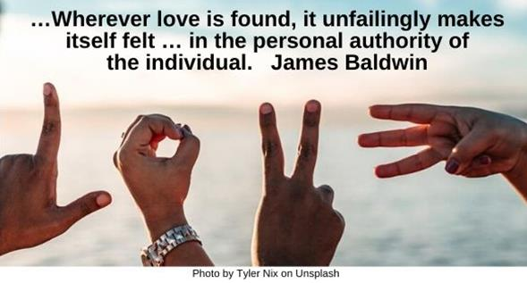

Mature HRJ

Mentor HRJ

Mount Rushmore HRJ

Pope HRJ

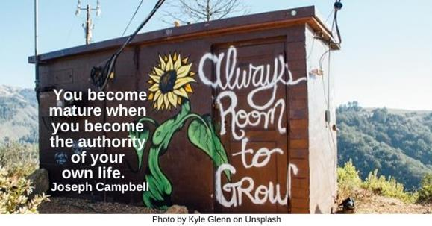

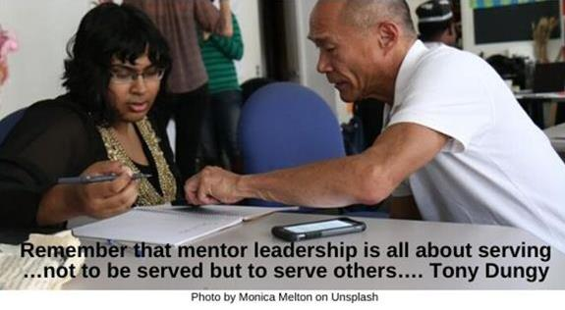

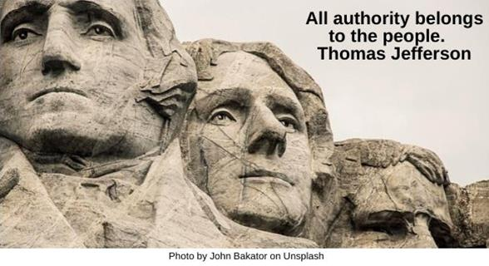

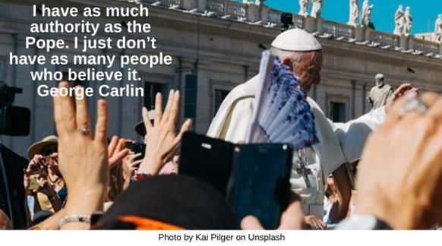

Responsibility HRJ

Shepherd HRJ

Truth HRJ

Two Routes HRJ

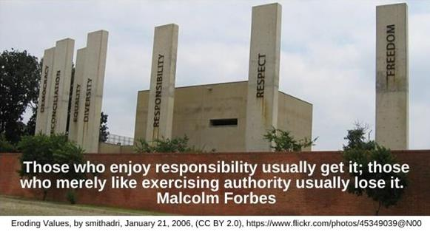

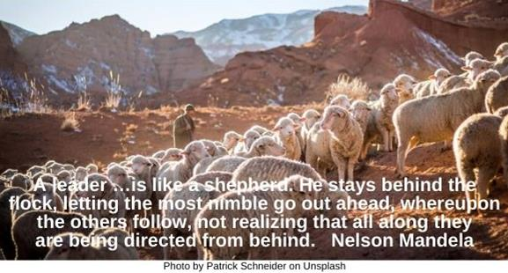

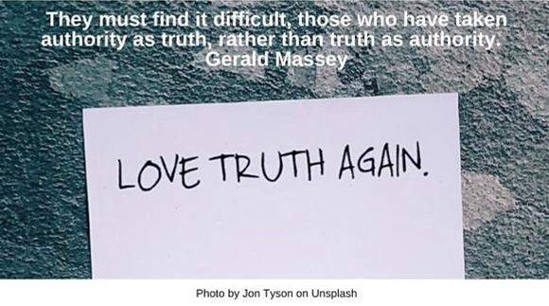

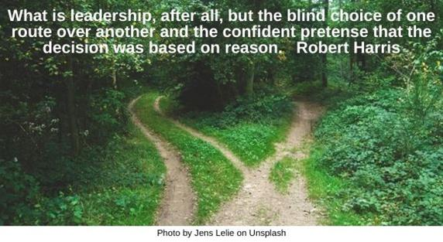

Universe HRJ

Wise HRJ

Wrong Way HRJ

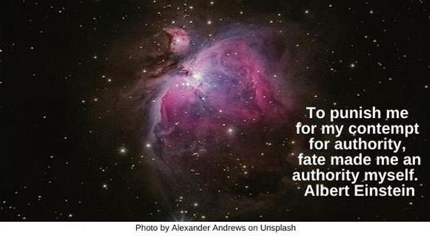

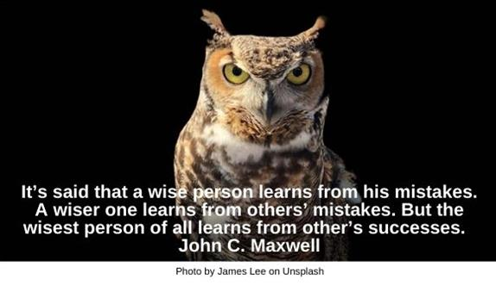

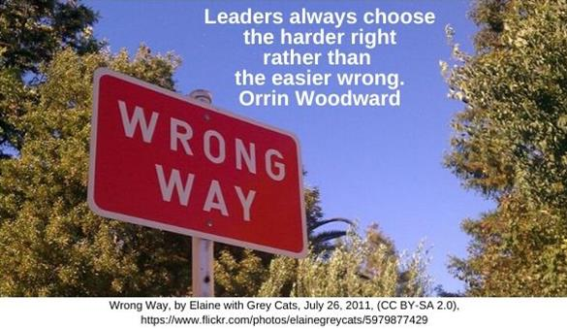

Success HRJ

The Poor HRJ

Too Late HRJ

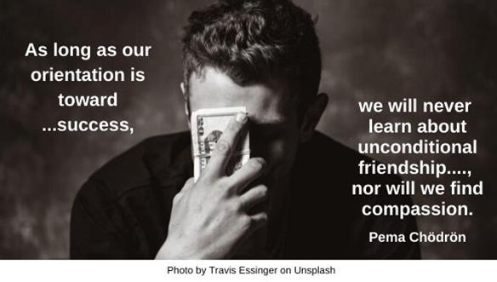

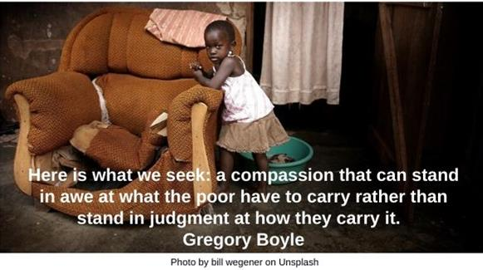

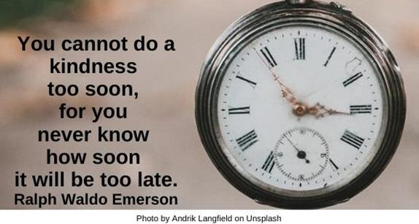

Understanding HR

Unseeing HRJ

Verb HRJ

Yourself HRJ

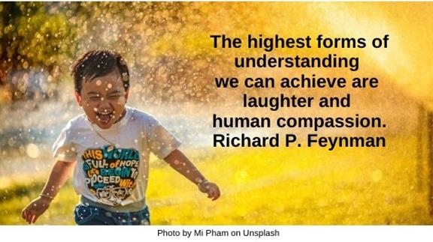

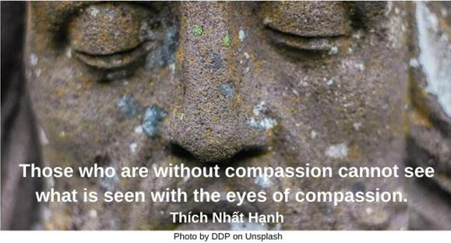



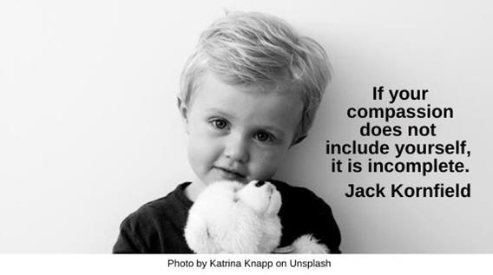

**Text of Quotes**

Axe

Authority without wisdom is like a heavy axe without an edge, fitter to bruise than polish. Anne Bradstreet

Boss

There is a difference between being a leader and being a boss. Both are based on authority. A boss demands blind obedience; a leader earns his authority through understanding and trust. Klaus Balkenhol

Buddha

Do not believe in anything merely on the authority of your teachers and elders. Buddha

Celebrate

It is better to lead from behind and to put others in front, especially when you celebrate victory…. You take the front line when there is danger. Nelson Mandela

Comfort Zone

Leadership begins when you step outside your comfort zone. Roy T. Bennett

Darkness

We’re here for a reason. I believe a bit of the reason is to throw little torches out to lead people through the dark. Whoopi Goldberg

Dawn

To all those watching tonight from …, our stories are singular, but our destiny is shared, and a new dawn of American leadership is at hand. Barack Obama, Election Night, November 7, 2008

Desert

The great illusion of leadership is to think that …[people] can be led out of the desert by someone who has never been there. Henri J.M. Nouwen

Dream

If your actions create a legacy that inspires others to dream more, learn more, do more and become more, then, you are an excellent leader. Dolly Parton

Einstein

Unthinking respect for authority is the greatest enemy of truth. Albert Einstein

Flag

We must dissent from the poverty of vision and the absence of moral leadership … because America has no choice but to do better. Thurgood Marshall

Galileo

For in the sciences, the authority of thousands …is not worth as much as one tiny spark of reason in an individual man.

Gandhi

Moral authority is never retained by any attempt to hold on to it. It comes without seeking and is retained without effort. Mahatma Gandhi

Ideas

Leadership is the art of giving people a platform for spreading ideas that work. Seth Godin

Ignore Authority

Oh, he teaches us to respect authority…. He just teaches us to ignore it when necessary. John Flanagan

Imagination

Authority is itself inherently an act of imagination. Richard Sennett

Jazz

To be a jazz freedom fighter is to attempt to galvanize and energize world-weary people into forms of organization with accountable leadership that promote critical exchange and broad reflection. Cornel West

Ladder

Leadership is …two-way…, loyalty up and loyalty down. Grace Murray Hopper

Line

The line between firmness and harshness, between strong leadership and bullying, …is very fine, but it has to be drawn. A.P.J. Abdul Kalam

Love

…Wherever love is found, it unfailingly makes itself felt … in the personal authority of the individual. James Baldwin

Mature

You become mature when you become the authority of your own life. Joseph Campbell

Mentor

Remember that mentor leadership is all about serving …not to be served but to serve others…. Tony Dungy

Mount Rushmore

All authority belongs to the people. Thomas Jefferson

Pope

I have as much authority as the Pope. I just don’t have as many people who believe it. George Carlin

Responsibility

Those who enjoy responsibility usually get it; those who merely like exercising authority usually lose it. Malcolm Forbes

Shepherd

A leader …is like a shepherd. He stays behind the flock, letting the most nimble go out ahead, whereupon the others follow, not realizing that all along they are being directed from behind. Nelson Mandela

Truth

They must find it difficult, those who have taken authority as truth, rather than truth as authority. Gerald Massey

Two Routes

What is leadership, after all, but the blind choice of one route over another and the confident pretense that the decision was based on reason. Robert Harris

Universe

To punish me for my contempt for authority, fate made me an authority myself. Albert Einstein

Wise

It’s said that a wise person learns from his mistakes. A wiser one learns from others’ mistakes. But the wisest person of all learns from other’s successes. John C. Maxwell

Wrong Way

Leaders always choose the harder right rather than the easier wrong. Orrin Woodward